Domain Registration
and Web Hosting

If you decide to have a web presence on the internet, you must perform the following two tasks.

- You must choose a web hosting service to store and deliver your content.
- You must register a unique web address (called a domain name)

Step 1 - Choosing a Web Hosting Service

A web hosting service is an organization that has setup one or multiple computers that are connected to the internet, and run special software (such as web servers, ftp services, email services, firewalls, etc). These organizations are willing to share (i.e. rent) those services to you for a fee. As part of this fee, you are entitled to host (i.e. store) your web pages on their computers, allow visitors to view those pages, be able to access and update those pages, be able to have email accounts, etc.

There are many web hosting organizations out there, each claiming that they provide the best services at the cheapest price, etc, etc. You need to investigate these for yourself, and determine the level of service that you want, and the price you are willing to pay for it.

To get a list of those organizations, simply key in the phrase “web hosting” in any search engine. You will get over 100+ organizations. Some of those are:

http://www.ipowerweb.com/
http://www.startlogic.com/
http://www.aplus.net/
etc.

Once you researched their offerings, and have decided on the “right” organization for your needs. You will need to setup an account with them. You can either do this online through their web site, or you can call their customer support line (if they have one).

As part the setting up an account, you will be given, or can choose a user name (sometimes also referred to as a userid, or a screen name, etc.), as well as a password. You will need the user name and password to access their site computers, to store your web pages.

Some web hosting organizations (example www.aplus.net) also offer domain name registration (see next topic).
- If you choose to register a domain name with such organization, the process is somewhat easier.
- If on the other hand you choose to use a separate organization to register your domain name,
you must obtain the IP address of the web hosting company’s computer. You will need this to complete step 2 below. An IP address is a 4 parts number, each part can be in the range of 0 to 255. These 4 parts are connected together with dots. Example: 66.226.64.23

Step 2 - Registering your Domain Name

A domain name is a unique name that you try to establish for yourself. This name has to be unique, and must not have been registered before you by someone else. You should come up with a name that is either “catchy”, or that represents the service that you will be providing in your web site. Example www.EasyWebClass.com

You need to register this unique name. There are many organizations that help accomplish that, each claiming that they provide cheapest price, etc, etc. You need to investigate these for yourself, to see which offer best suits your need. Do you want to register for one year, or two? What do they charge for registration renewal? etc.

To get a list of those organizations, simply key in the phrase “domain registration” in any search engine. You will get over 100+ organizations. Some of those are:

http://www.register.com
http://www.networkSolutions.com
http://www.aplus.net
etc.

Within this list, you might see an organization that also provides web hosting services, (example www.aplus.net) . This is not uncommon. As a matter of fact nowadays this is more the norm. These organizations will allow you to both host your web site, as well as register your domain name. They may even waive the registration fee if you sign up for web hosting with them.

Once you have chosen an organization to register your domain name with, you will need to setup an account with them. You can either do this online through their web site, or you can call their customer support line (if they have one).

Within the registration process, you will be able to check to see if your domain name is unique, and if it is not currently being used by anyone else, if it is, you will need to choose another name, and repeat the process.

If you are not using the same organization for both web hosting and registration, you will need to specify the IP address from step 1. (see above – web hosting)

There are two goals for domain registration, they are:

- To register a unique name such as www.easywebclass.com
- To associate that name with an IP address where you indent to serve a web site.

Finally, when both step 1 (web hosting) and step 2 (domain registration) are complete, you can now create a web site that is made up of multiple web pages, host (i.e. store) those pages on the web hosting company’s computer (you do that by ftp’ing those pages from your local computer to the hosting company’s computer). And finally, get the general public to view those pages by typing your domain name in a browser window.

Using a browser, enter http://www.aplus.net



Click on Domain names

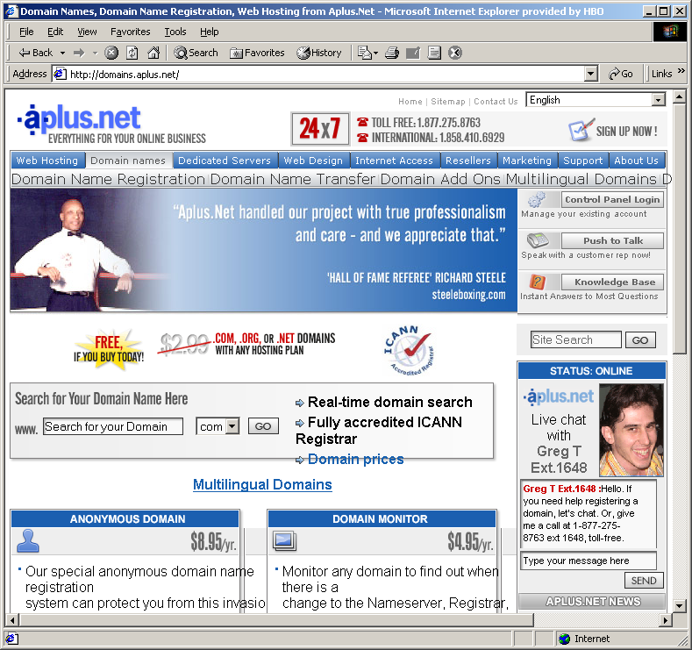

Enter your desired domain name (do not enter .com). And click the Go button
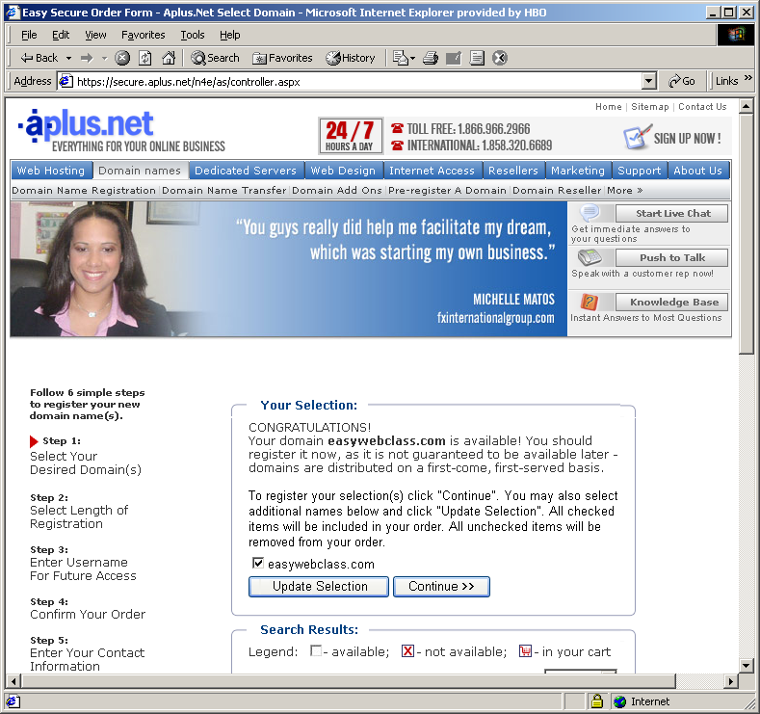

If successful, click the Continue >> button. If domain name is taken, try again.

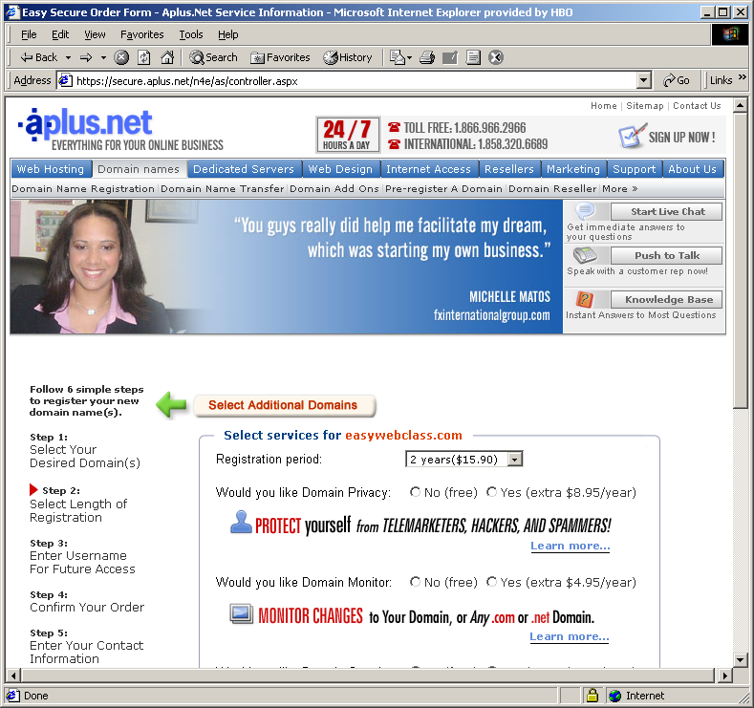

Select 1 year ($7.95) plan, and click on all the no options.
Select hosting plan solo ($5.95) option, and click on the Continue >> button
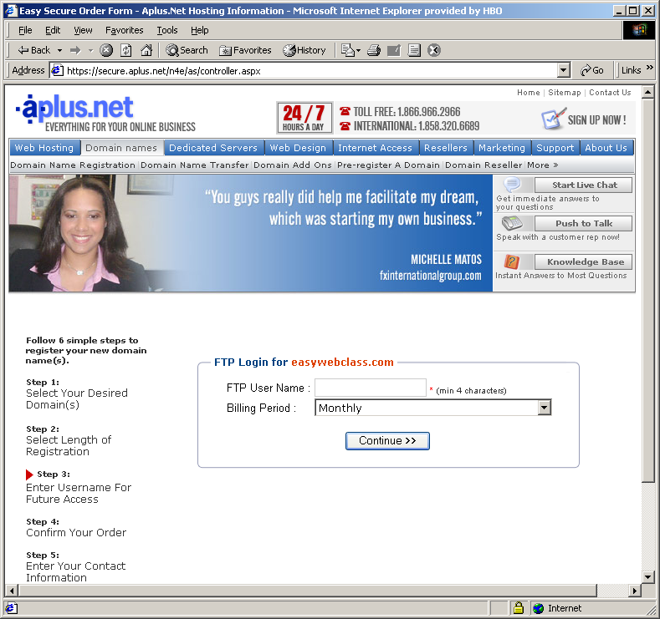

Enter an FTP User Name. This can be your domain name, or something else. Continue >>

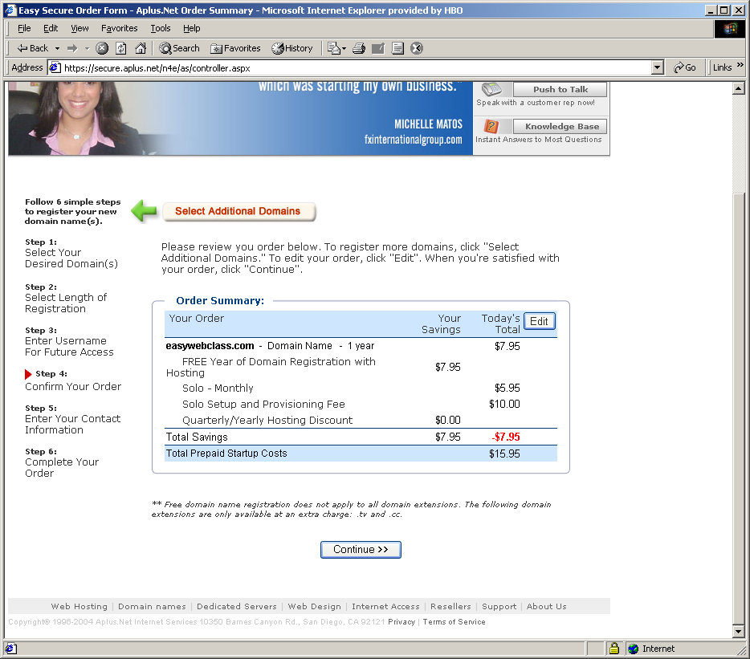

Verify that the total price is $15.95, and click the Continue >> button
Notice that the domain name registration fee has been waived
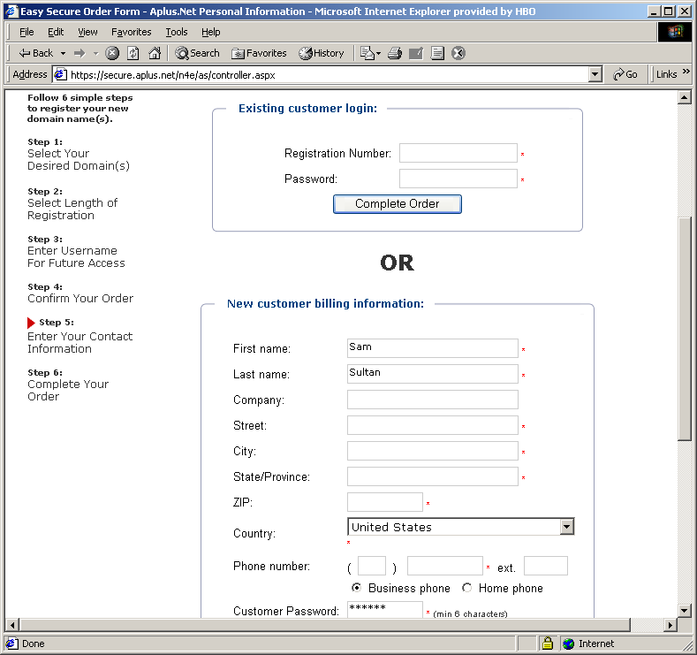

In the New customer section, enter your name, address and other billing information
Choose and enter a Customer Password for yourself. Click the Continue >> button

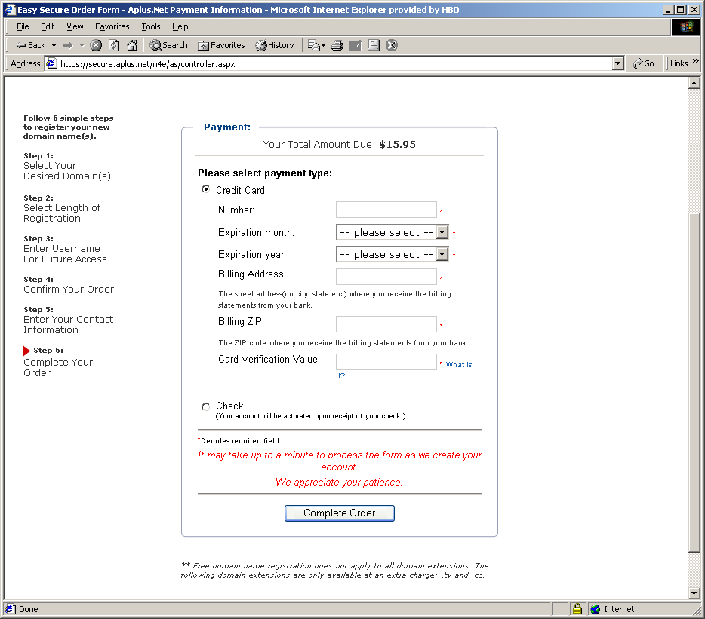

Enter Credit Card information, or choose check option. Click on Complete Order

If you would like to see the services you have, return to the main page.
Hover over the Web Hosting menu option, and click Unix Hosting
Click on Compare plans

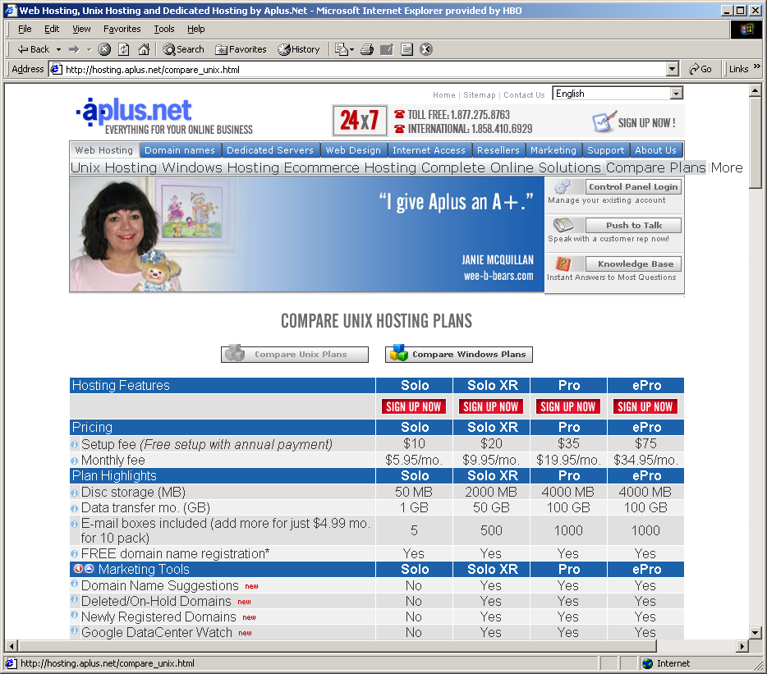

Congratulations…

You have now completed both steps (web hosting and domain registration).

- Web hosting is a monthly service fee (perhaps paid quarterly or annually),
- Domain registration is an annual fee. If not renew, your domain name will be reclaimed.

Your domain name will take about 24 to 72 hours to be replicated to all DNS name servers through the world. Once that is done, you can go to any browser and type your domain name as http://yourDomainName, and you should get the introductory page for your site.

Create one or more web pages on your local computer.
Transfer (i.e. FTP) those pages to the web hosting service computer.
You can use a program such as WS_FTP or FTP Voyager. (Download from the web).

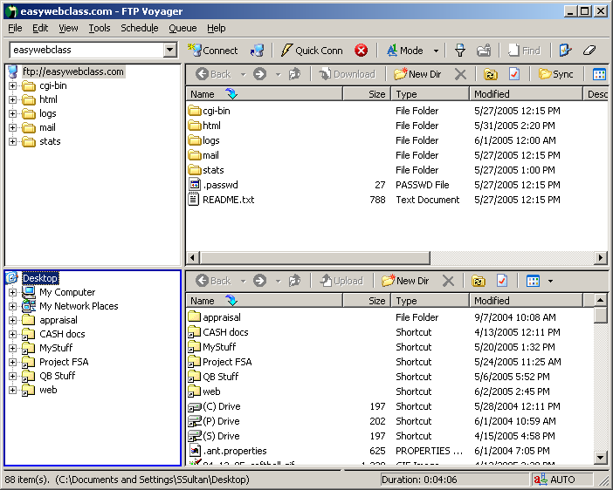

or you can enter ftp://yourDomainName on your browser window



